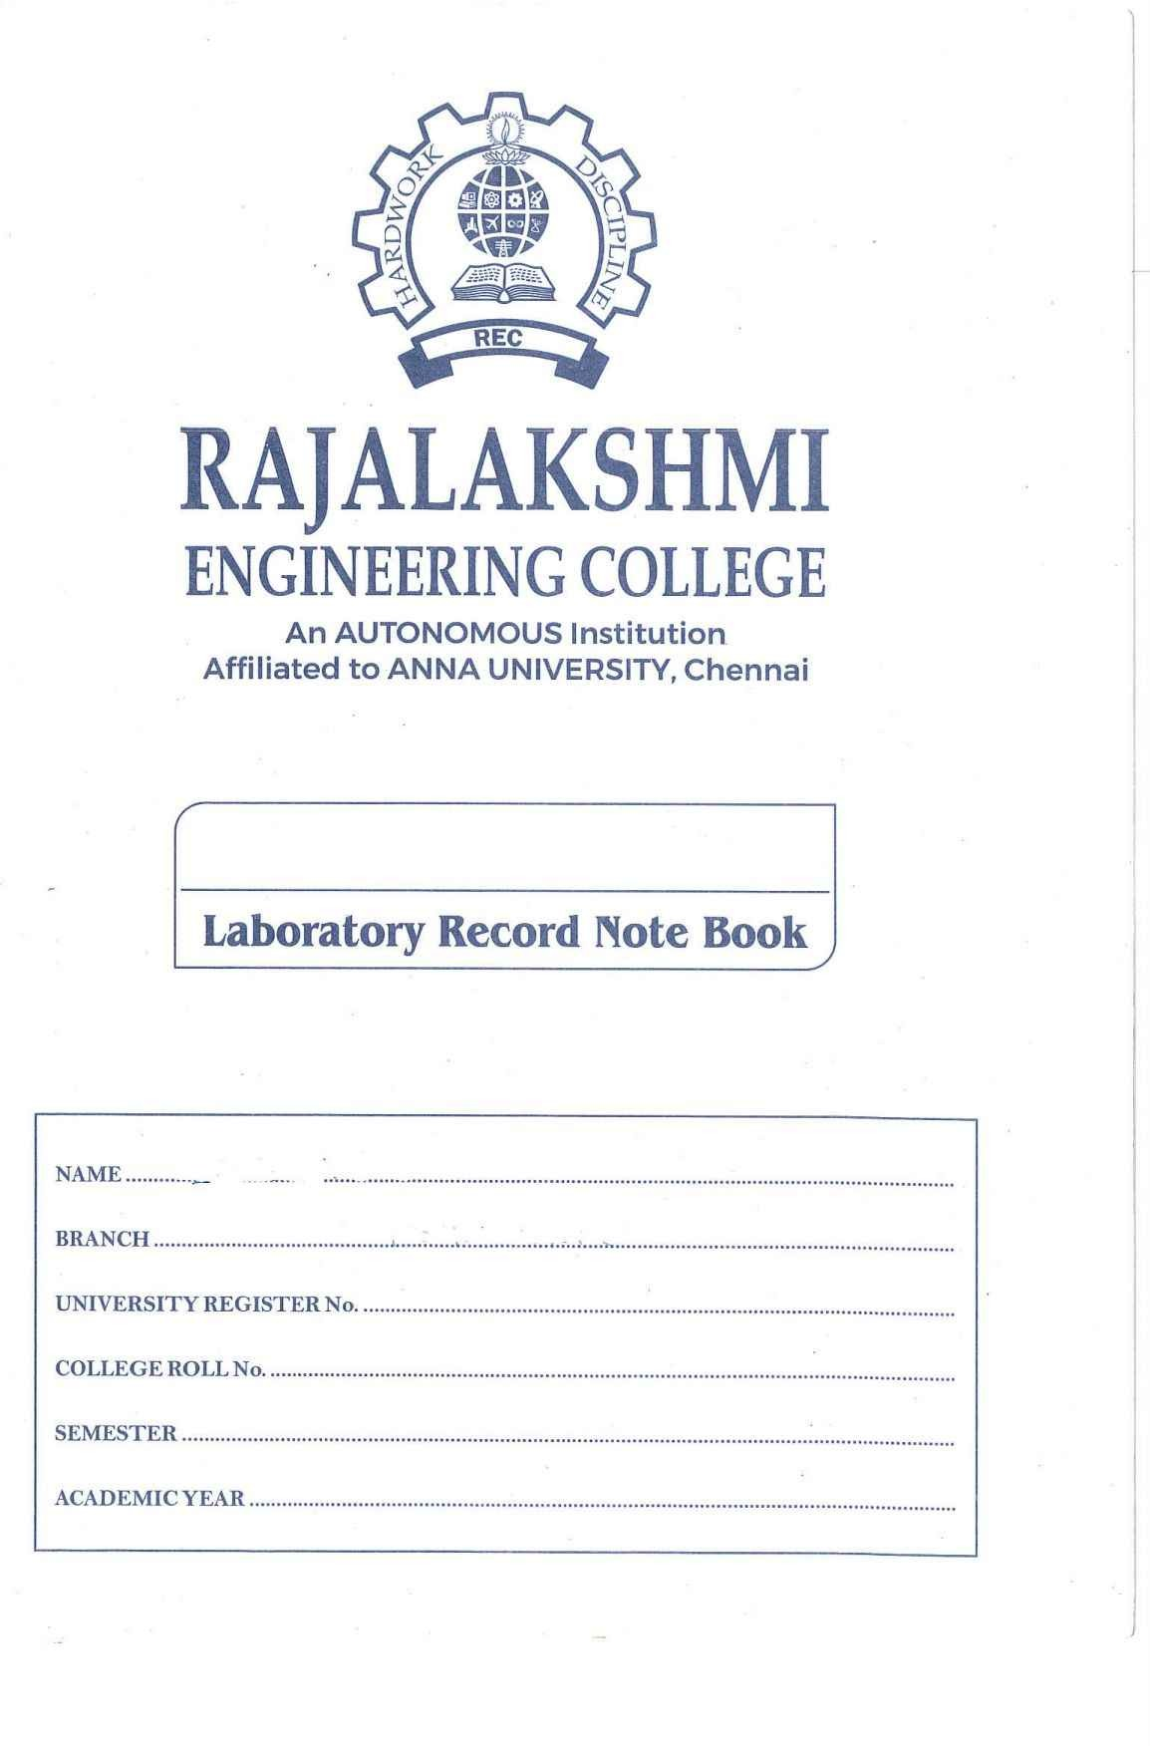

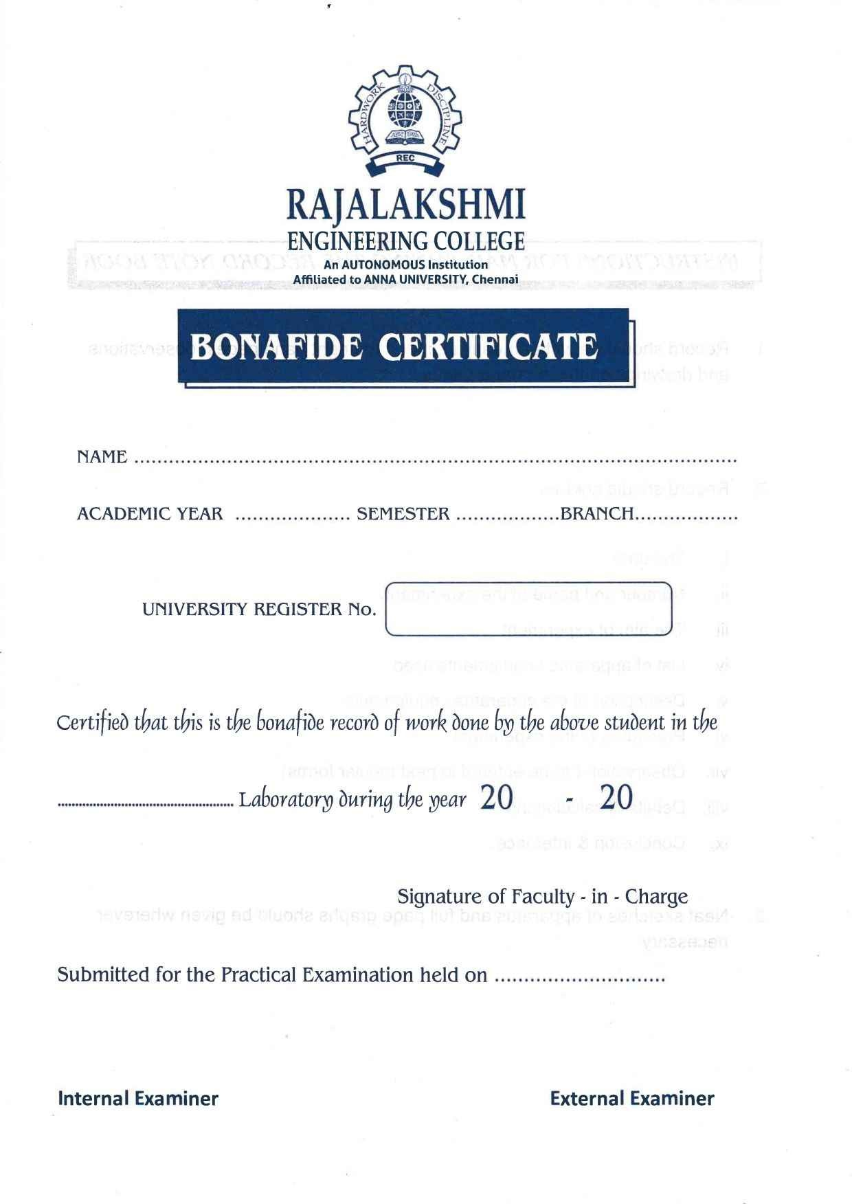

**Rajalakshmi Engineering College (Autonomous)**

**Chennai-602105**

|  |  |  |  |
| --- | --- | --- | --- |
| SI.No | Date | Name of the experiment | Signature |
| 1. | 15/2/2024 | Calculating values of random data using NumPy for mathematical formulas  1)Euclidean distance between two points 2) Dot Product of two Vectors 3)Solving a System of Linear Equations |  |
| 2. | 29/2/2024 | Write a simple Python code to generate random values and then compute their sigmoid and tanh (hyperbolic tangent) values using NumPy. Plot the values. |  |
| 3. | 7/3/2024 | simple Python program using pandas that creates a DataFrame, performs some basic operations, and  prints the result. |  |
| 4. | 14/3/2024 | Store and Load Excel / CSV files. |  |
| 5. | 21/3/2024 | Data Visualization |  |
| 6. | 11/4/2024 | Time Series |  |
| 7. | 25/04/024 | Linear regression model to predict the signal strength |  |
| 8. | 02/05/2024 | A component is defective or not based on Voltage and Current |  |
| 9. | 3/5/2024 | Decision tree classifier to predict signal quality based on transmitter, signal strength, and frequency |  |
| 10. | 09/5/2024 | k-NN classifier to predict signal quality based on distance from the transmitter, signal strength, and frequency |  |
| 11. | 16/5/2024 | Study of Artificial Neural Network (ANN) and Simple Program in ANN |  |
| 12. | 23/5/2024 | Study Of Support Vector Machine and and Simple Program in SVM |  |

**CS19411 Python Programming for Machine Learning**